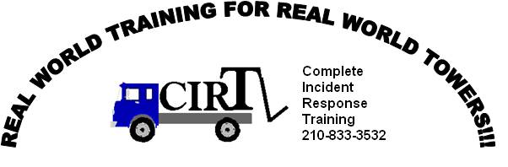

TOP 10 GOOD REASONS FOR TOW OPERATOR TRAINING

1. Reduce Damage Claims: The cost of doing damage to a customer’s vehicle is not only measured in dollars, but in the loss of a future tow and customer. Training doesn’t cost, it pays!
2. Vehicle Change: New models hit the market every year.
3. Towing & Recovery Techniques Change: Just as new models change every year, the way we tow and recover those vehicles has to change.
4. Develop Self-Confidence: Quality training helps a tow operator feel like he/she has the needed skills to safely handle most situations the tow operator will face.
5. Networking with Other Towers: Training is a good way to meet other towers and a chance to share information and ideas.
6. Increase Your Personal Safety: This may be the single most important reason for training.
7. Increase Others Safety: Your actions can result in others being injured while performing your job.
8. Law Suits: Being sued seems to be part of everyday life. As a tow operator or tow company owner, I would much rather be able to tell my insurance company and the attorneys that I have some level of documented training.
9. State Requirements: As of 9/1/2008, The Texas State Legislature voted to task The Texas Department of Licensing & Regulation with issuing state licenses to all tow truck operators in Texas. These licenses have various requirements, but all tow operator licenses require Continuing Education once a year in order to renew the license.
10. Personal Development: Because Texas requires Continuing Education through the TDLR should not be the only reason to seek out training, becoming a safer tow operator should also be a reason.

Training Is Training Right?

Choosing a Training Class / Classroom vs Internet Classes
- Different types of training classes are offered for all levels of towing.
- Don‘t be afraid to ask any training provider what topics the course covers.
- What techniques are performed during hands-on training.
- Classroom Instructor versus Internet Courses – Classroom training with an instructor offers the student a chance to ask questions on things they may not fully understand. Internet courses are mostly: read, pay, and walk away
- Classroom training with an instructor offers the student a opportunity to ask a question about a towing technique that may not have been part of the course but is something they have always questioned
- Classroom training also offers the students a chance to share experiences both good and bad with other students.
- And finally, quality classroom based training is about: Ask and understand, by using your hands!!!

